Nathan Long, Brice Martinelli

AEEM 3042

Aircraft Performance and Design

Due 28 March 2023

Homework 16

Aircraft Research Synopsis

**Boeing-737 MAX 7:**

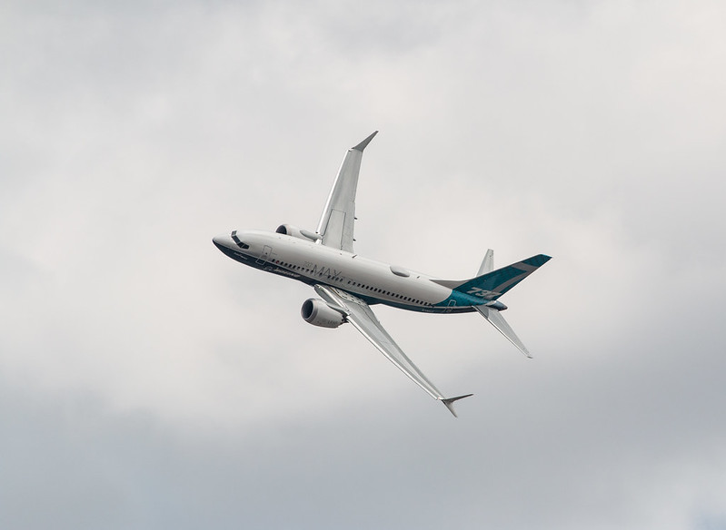

**Figure 1: Boeing 737 Max 7 Test Flight (1)**

The entire 737 MAX series is manufactured by The Boeing Company. The MAX 7 series, a variant of the MAX 8, took its first test flight on March 16, 2018 (2). The aircraft costs approximately $99.7 million (2) with 27 having already been built. However, all orders are currently backlogged and as of Boeing’s December 2022 tax filing there are 236 outstanding orders (3). The main competitors to Boeing’s 737 MAX 7 are the new narrowbody aircrafts, Airbus’ A319neo and the Russian Irkut MC-21-200 which the MAX 7 outperforms in both range and operating cost per passenger (4). Currently, there are no military variants of the 737 MAX series however, there do exists several military variants of older 737’s, notably the 737 AEW&C, C-40 Clipper, and P-8 Poseidon (5). Since this model has not even been officially released yet there are not many interesting facts, the main difference between this plane and its predecessor are its improved fuel efficiency and slightly larger size.

**Boeing-737 MAX 8:**

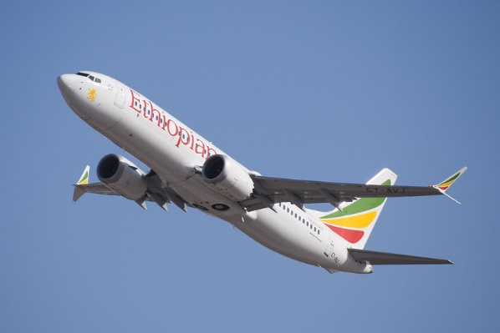

**Figure 2: Ethiopian Airlines 737 Max 8 (6)**

The Boeing-737 MAX 8, built to replace the 737-800, is the first of the MAX series of aircraft. Its first flight took place on May 2, 2016, in La Paz, Bolivia. It costs approximately $121.6 million (7), and as of June 2022 had nearly 2,300 orders compared to 281 of the MAX 9 (8). Specific numbers for fulfilled and outstanding orders could not be found but using this ratio of MAX 8 versus MAX 9 and the known orders of MAX 7 and 10 variants we can approximate that about 2,900 of Boeing’s unfulfilled MAX orders are MAX 8’s and that around 1,000 of these orders have been fulfilled (9). The main competitor of the MAX 8 is the Airbus A320neo and boasts a higher maximum takeoff weight and slightly longer range however, the engines used on the A320neo tend to have a slightly higher fuel efficiency (10).

The MAX 8 has had a relatively torrid history as it was involved in two separate crashes stemming from a malfunctioning flight-control system which pilots did not know how to disengage. These incidents resulted in a grounding of all MAX 8’s for over a year and a half until the issue could be resolved (11).

**Figure 3: United Airlines Boeing 737-Max 9 (12)**

The 737-Max 9 was manufactured by Boeing from 2014 to 2020 and was sold at $128.9 Million US (2019 price). It first took to the skies on April 13th during its inaugural flight from Renton Field to Boeing Field(14). Flight tests began shortly after, conducting 30% of the tests completed by the Max 8 as well as model-specific tests (13). On March 21st, 2018, the first plane was delivered to Lion Air Group (13). There were 281 orders of the MAX 9 by June 2022 (8), and up to 306 orders by July 18, 2022 (15). There seem to be no backlogged aircraft as I could not find any specifics on the deliveries of the Max 9. The Airbus 320neo is a competitor of the Max 9 from the Airbus family, which seats 195 compared to the Max 9’s 193. The two planes also exhibit similar ranges with the max 9 beating the A320neo by 50 NM. Despite the similar ranges and standard seating, the Max 9 has more power with a larger max payload verses Airbus’s challenger, while also allows for a 220-seater variation. Lastly, the Max 9 is about US$18 million more than the A320neo which costs US$110.6 million (19). None of Boeing’s Max models have military variations.

The Boeing’s reputation was damaged severely due to the two crashes detailed in the Max 8 section, and it took rigorous re-testing of the variants with strict oversight from the FAA to re-enter the Max 8/9’s into the workforce. Due to these events, the Max’s orders never fully recovered especially paired with the Pandemic from 202-2021, allowing Airbus to outpace Boeing’s orders and deliveries (19).

**Boeing-737 MAX 10:**

**Figure 4: United Airlines Boeing 737-Max 10 First Flight (20)**

Boeing’s 747-Max 10 had its first flight on November 18th, but it is yet to finish the certification process. Boing is hoping to expedite the certification process, but there may be multiple needed changes in the aircraft before the process is complete (20). According to their tax filings, FAA certification flight tests are to occur in 2023 and the first delivery is expected in 2024 (3). However, the Max 10 completed its Maiden flight in late 2019 (18). There have been a total of 720 Max 10’s in backlog as of December of 2022 with no orders fulfilled, and 920 orders as of February 2023 (3, 15). At US$134.9 million, the 737-Max 10 is the most expensive in the 737 series with a 6 million dollar increase from the next highest, the Max 9 (17). Boing’s largest max variant can seat 204 passengers with a range of 3,300 NM; on the other hand, Airbus’ A321neo can seat 240 passengers with a 4,000 NM range (19). Both of these paired with Boeing’s recent issues with the max series puts Airbus as a more likely option for customers to go to.

As previously stated, the max series have no current military variations. Due to the increase in length of the Max 10’s fuselage, Boeing had to devise a solution to avoid tail strike on rotation at takeoff. They did this by making the main gear able to extend on rotation with a spring loaded lever while still being able to retract into the wheel wells which are the same size as the other variants.

**References**

1. <https://www.flickr.com/photos/lynothehammer/43406207022/>
2. <https://aerocorner.com/aircraft/boeing-737-max-7/>
3. <https://www.sec.gov/ix?doc=/Archives/edgar/data/12927/000001292723000007/ba-20221231.htm#idab206f38af44c3b82edc252bb6a3941_184>
4. <https://simpleflying.com/boeing-737-vs-a320-vs-mc-21/>
5. <https://simpleflying.com/boeing-has-built-22-variations-of-the-737/>
6. <https://www.flickr.com/photos/newfz28user/46461974574/https://aerocorner.com/aircraft/boeing-737-max-8/>
7. <https://aerocorner.com/aircraft/boeing-737-max-8/>
8. <https://simpleflying.com/737-max-variants-differences/#:~:text=Boeing%20estimates%20that%20the%20average,passengers%2C%20depending%20on%20the%20configuration>.
9. <https://www.boeing.com/commercial/#/orders-deliveries>
10. <https://aviationforaviators.com/2022/12/23/the-boeing-737-max-vs-airbus-a320neo/>
11. <https://www.reuters.com/business/aerospace-defense/boeing-737-max-makes-first-passenger-flight-china-since-march-2019-2023-01-13/>
12. <https://www.flickr.com/photos/85464137@N00/52583638240/in/photolist>
13. <https://aerocorner.com/aircraft/boeing-737-max-9/>
14. <https://www.boeing.com/company/about-bca/washington/737-max9-first-flight-04-14.page>
15. <https://en.wikipedia.org/wiki/List_of_Boeing_737_MAX_orders_and_deliveries>
16. <https://investors.boeing.com/investors/fact-sheets/default.aspx>
17. <http://www.b737.org.uk/sales.htm>
18. <https://www.modernairliners.com/boeing-737>
19. <https://simpleflying.com/the-airbus-a320neo-vs-boeing-737-max-what-plane-is-best/>
20. <https://simpleflying.com/united-airlines-first-boeing-737-max-10-flight/>